ASSIGNMENT

Create the project for any web application example using agile methodology (SCRUM TEMPLATE).

I. Create components

II. Plan the version with release dates

III.Create sprint backlog, start sprint and complete sprint

IV.Create different types of issues in the backlog.

-Epic –provide epic link also

- Story

Initialize story point, Associate with Version, component ---Divide into sub-tasks

Give estimate time

Give time log work and comment it as well. -Clone the story.

-task

-bug - Link with issues story

View workflows also.

V. Evaluate burn down, burn up, analyse the sprint report and velocity charts.

Submit the screen shots of Backlog, burn down, burn up, sprint report and velocity charts for the sprint.(From your login only)

1. Create components

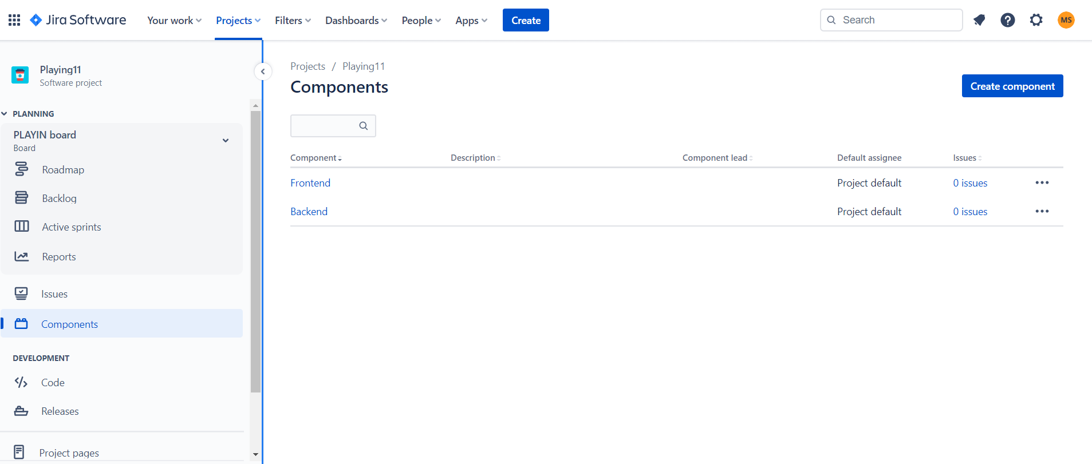

1. Plan the version with release dates

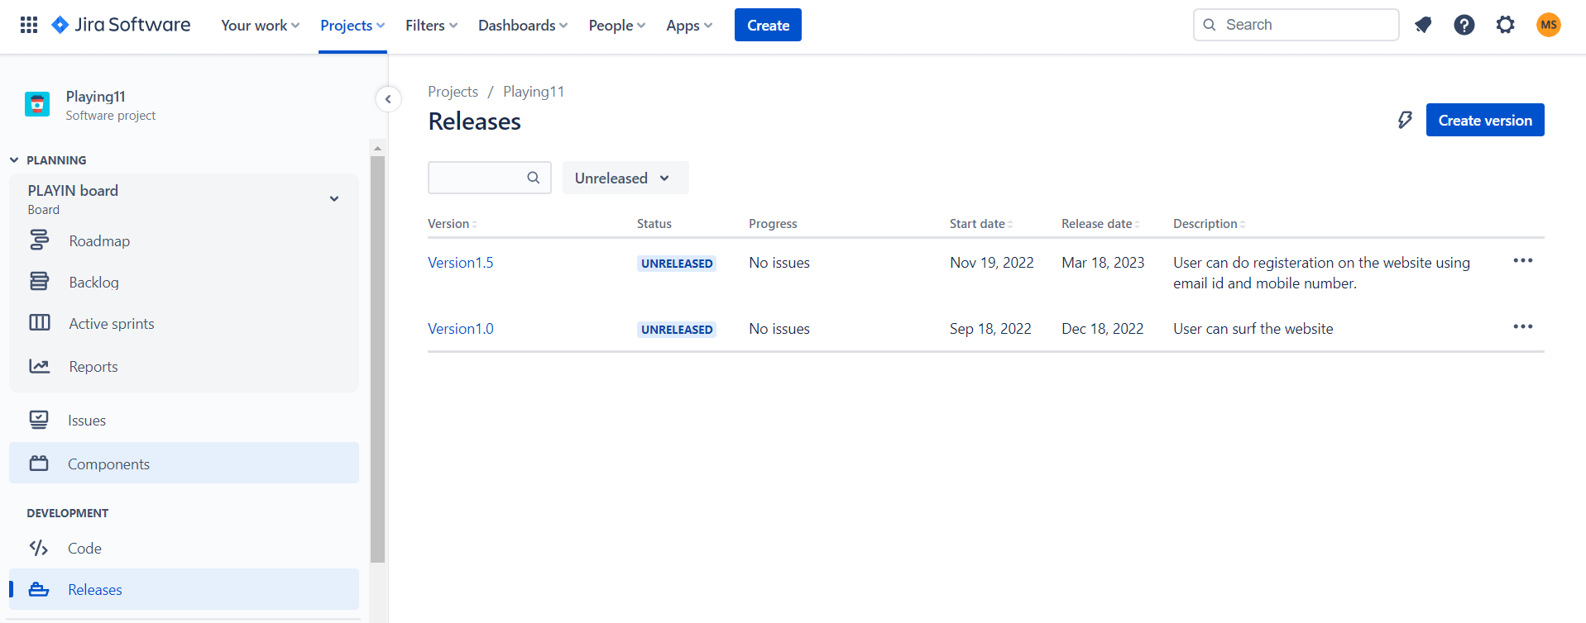

1. Create sprint backlog, start sprint and complete sprint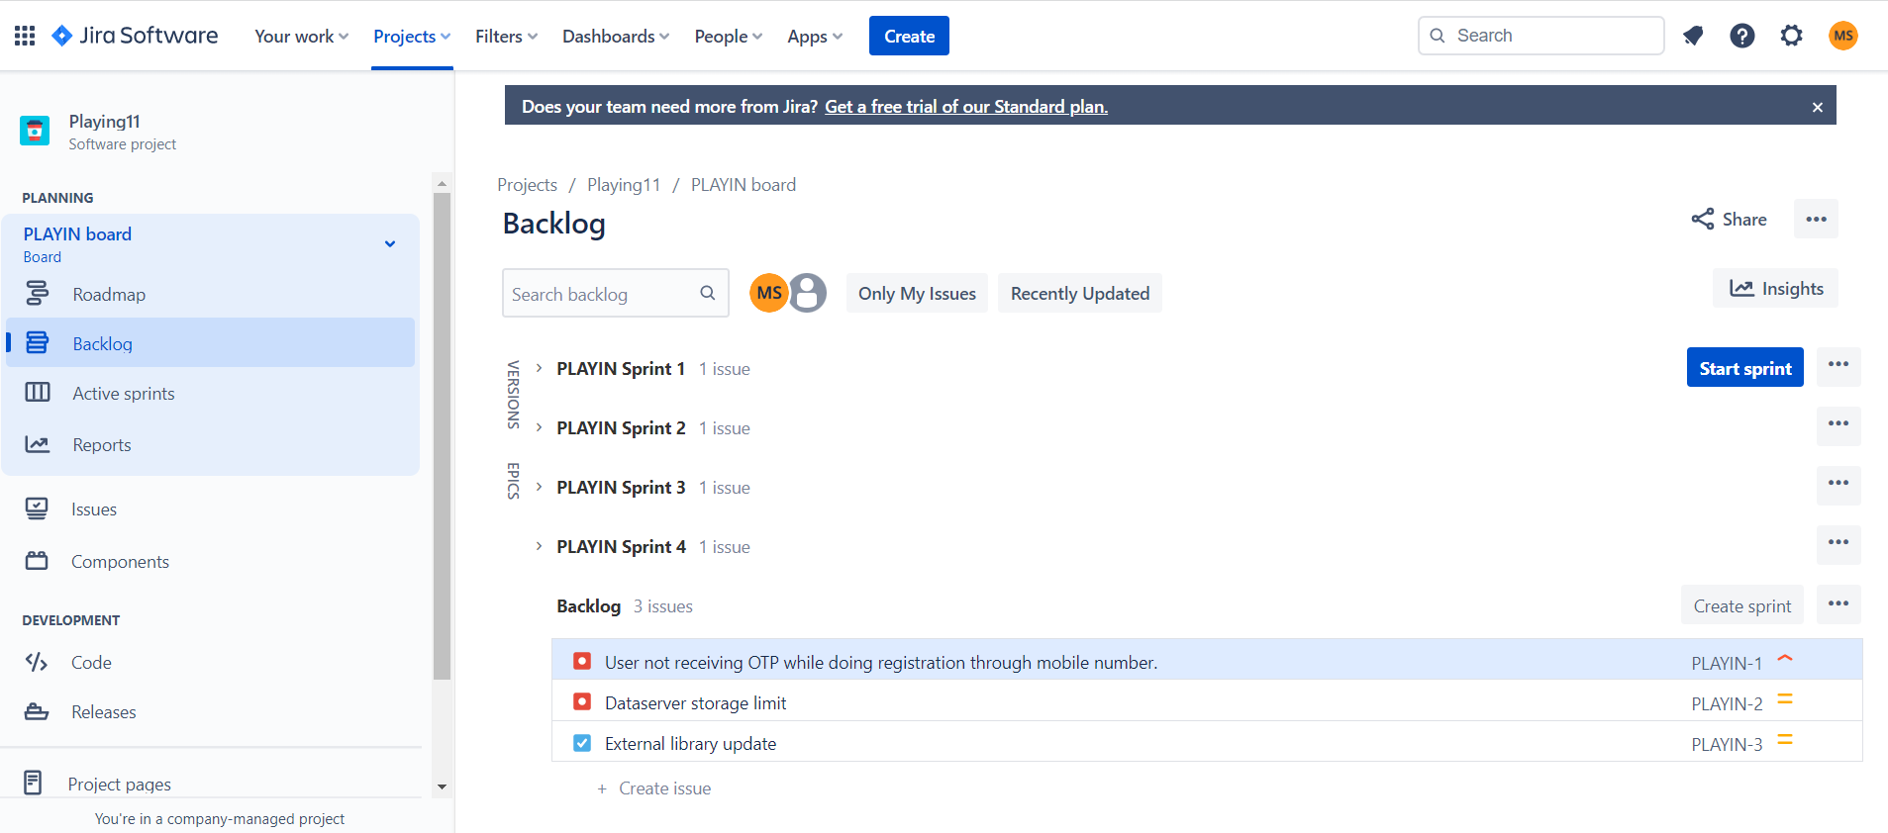
2. Create different types of issues in the backlog.
3. Epic

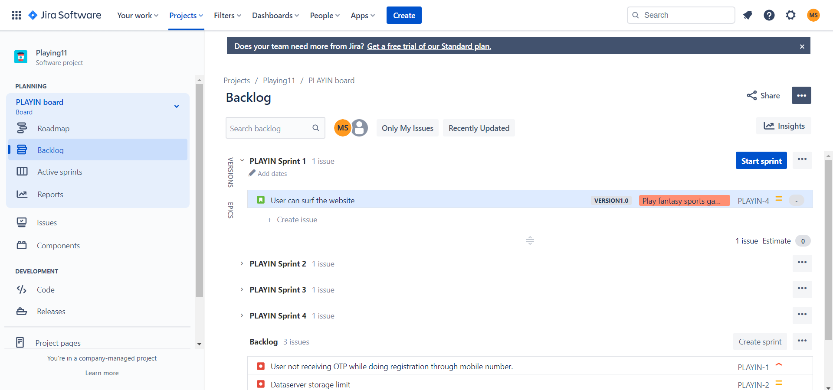

1. Story

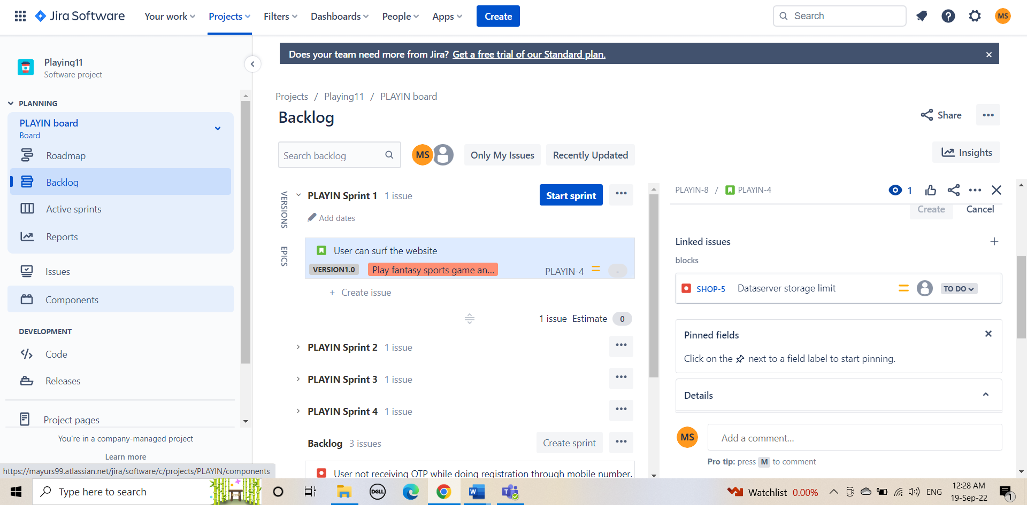

C. Bug

